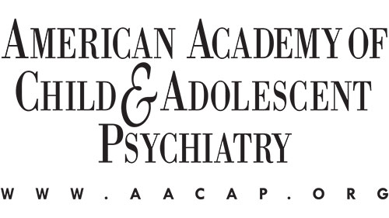

AACAP Educational Outreach Program (EOP)
Enrollment Verification and Recommendation Form

This form is to be completed by the Residency Program Director

TO: Residency Program Director

FROM: Educational Outreach Program Selection Committee

APPLICANT NAME:

DATE:

The above named applicant is applying to the AACAP Educational Outreach Program (EOP). Please complete the sections below, ensuring that you type or print the information legibly.

RESIDENCY PROGRAM ENROLLMENT VERIFICATION

As part of the application process, you must verify that the applicant is in good standing at their residency program. Please complete and upload this form using the instructions in the email titled “AACAP Awards Submission Endorsement Request” from aacap2@confex.com. You’ll receive this email after the applicant lists you as an endorser. If you encounter difficulties uploading the form and letter, please return the completed forms to training@aacap.org. Your assistance is appreciated.

Name of Residency Program Director:

Name of Institution:

Type of Training:

Child and Adolescent Psychiatry Program General Psychiatry Program
Pediatric Program Triple Board Program
Post Pediatric Portal
Other:

Date Started in Program: Anticipated Completion Date:

Is the applicant in good standing in the residency program? Yes No

RECOMMENDATION

Please use the following form to submit a letter of support indicating how long you have known the applicant, and in what capacity. In describing the applicant, it would be helpful to address the applicant’s training, qualifications, accomplishments, interest in the CAP specialty, motivation for this award, and the potential benefits of the applicant attending the Annual Meeting both for your program and AACAP, as appropriate.

Award Recommendation Form

Name of Mentor/Endorser:

Title:

Institution:

Please provide comments regarding the applicant as follows:

- Briefly provide background specific to your relationship with the applicant:

- Qualities of applicant. Examples of key areas may include but are not limited to:
- Leadership
- Community Service
- Clinical Work
- Teaching
- Research and Scholarly Work
- Unique Qualities

- Applicant’s level of interest in Child and Adolescent Psychiatry:

- Value of applicant attending the in-person AACAP Annual Meeting:

- Benefit to AACAP:

- Benefit to program:

- Summary or Other Comments: [Provide any additional information relevant to the applicant’s consideration for the award not addressed above.]

Signature: Date:

